Star tour and travel services

**A**

**PROJECT REPORT**

Submitted in partial fulfillment of the requirements for the degree of

##### BACHELOR OF TECHNOLOGY

in

##### COMPUTER SCIENCE & ENGINEERING

By

**0187CS221126 Monu Yaduwanshi**

##### Under the guidance of

##### Prof. Shumali Gupta

##### Assistant Professor



##### December-2023

##### Department of Computer Science & Engineering Sagar Institute of Science & Technology (SISTec) Bhopal (M.P.)

**Approved by AICTE, New Delhi & Govt. of M.P.**

**Affiliated to Rajiv Gandhi Proudyogiki Vishwavidyalaya, Bhopal (M.P.)**

**INDEX**

|  |  |  |
| --- | --- | --- |
| **TITLE** | | **PAGE NO.** |
| Chapter 1 | Introduction | 3 |
| Chapter 2 | Hardware and Software Requirement | 4 |
|  | Introduction | 4 |
|  | Software Requirement | 4 |
|  | Hardware Requirement | 5 |
| Chapter 3 | Coding | 6 |
| Chapter 4 | Output Screens | 24 |
| Chapter 5 | Conclusion | 29 |
| Chapter 6 | Future Work | 30 |
| References |  | 31 |

Project summary 32

# CHAPTER – 1 INTRODUCTION

Here I have developed a project on Tour and Travel. Online Tour and Travel Booking is a system that gives you the facility of booking any type of packages (Summer special packages, tour packages special packages, adventures etc). This system is made, so that customer can easily book ticket for all packages of tourist place such as hills, trekking, adventures, spirituals and user can also register for cars,buses,coach for different types of destinations.

The project 'Tours and Travels' is developed to replace the currently existing system, which helps in keeping records of the customer, details of destination as well as payment received. It saves the precious asset that is time, and also accuracy, reliability and uniformity can be maintained. This project is useful for the manager of the company as it helps them to search the data faster than existing system, to get customer record easily and report of the customer payment, etc are generated as per requirement.

Details of different types of tours which include tours like family tours, couple tours, general tours, date and time of departure and the fair of the tours etc are maintained. Through this site we can provide different types of travel packages to the customers. This sites provide everything related to it itineraries.

This site gives new packages on flexible price, so that user can book easily. The purpose of tour and travel is mainly to provide online booking services for the user. This statement describes the problem definition of the proposed system. The purpose of this site is to book online ticket for destination and all tourist places of India

The problem definition of the vacation-o-city is to book online ticket for tourist place where user wants to visit. It is a Web Application to develop website in which end user interact with the web-site easily. In this website, Customer or User can search and book all tourist places and all hill stations and all popular places of India

# CHAPTER-2

**SOFTWARE & HARDWARE REQUIREMENTS**

##### INTRODUCTION

This system provides Online bus booking, Tour Package Information, Bus ticket booking and all other destinations. The purpose of this project is very clear that user can find bus,coach,car facilities easily & h service providers also get good customers very easily. Customer can register in the website & can create his own registration then he can receive email for his vehicle status related to his reservation and book all packages. User can register car for different types of destination what they want.

The Main Goal of this project is to provide bus,car,coach services and also rental cabs booking services for different types of destination so any user can get this service very easily.

##### SOFTWARE REQUIREMENTS

* + - Operating System : Windows
    - Front-End : HTML, CSS, JAVASCRIPT
    - Software : Microsoft edge/Google chrome

##### HARDWARE REQUIREMENTS

* + - Processor: Dual-core 64-bit processor.
    - RAM: 2 GB(MIN.).
    - Hard Disk: 256GB (MIN.).
    - Proper Internet connection.

# CHAPTER 3 CODING

##### Coding

**Project.html**

 <!DOCTYPE html>

<html lang="en">

<head>

    <!DOCTYPE html>

    <html lang="en" dir="ltr">

    <head>

    <meta charset="UTF-8">

    <meta name="viewport" content="width=device-width, initial-scale=1.0">

    <title>Welcome to tour and travel</title>

    <link rel="stylesheet" href="Minorproject.css">

    <style>

        body {

            margin: 0;

            padding: 0;

            font-family: Arial, sans-serif;

        }

        header {

        background-image: url(wallhaven-0qd87q_2560x1080.png);

        background-size: cover;

        background-position: center;

            color: #fff;

            padding: 10px 0;

            text-align: center;

        }

        .logo {

            font-size: 24px;

            font-weight: bold;

        }

        .menu {

            list-style: none;

            padding: 0;

        }

        .menu li {

            display: inline;

            text-decoration: none;

        }

        .contact-info {

            font-size: 14px;

            margin-top: 10px;

        }

    </style>

</head>

</html>

       <header>

        <nav>

        <div class="IMG-20230919-WA0028">STAR TOUR AND TRAVEL Services

        </div>

        <!-- <img src="wallhaven-4yxoel_2560x1080.png" alt=""> -->

        <!-- <img src="stock-vector-travel-tour-logo-design-1302584098.jpg" alt="" height="100" width="1500"> -->

        <ul class="menu">

            <li><a href="Minorproject.html">Home</a></li>

                            <li><a href="about us.html">About Us</a></li>

                            <li><a href="gallery.html">Gallery</a></li>

                            <li><a href="feedbacl.html">Feedback</a></li>

                            <li><a href="complaint.html">complaint box</a></li>

                            <li><a href="payment.html">Pay Online</a></li>

                            <li><a href="bookingservice.html">My Bookings</a></li>

                            <li><a href="T&C.html">Terms &amp; Conditions</a></li>

                            <li><a href="privacypolicy.html">Privacy Policy</a></li>

                            <li><a href="contact.html">Contact Us</a></li>

                            <li><a href="login.html">Login</a></li>

        </ul>

        </nav>

        <div class="contact-info">

            <p>Email: info@yourtraveladventures.com</p>

            <p>Phone: +1 (123) 456-7890</p>

        </div>

        <div class="sectionheader paddefault">

            <div class="headertop">

                <div class="container">

                    <p>Payment &amp; Cancellation Issues: <a href="tel:7828454800,5462458745">565646,4544454

                    <p class="routeinq">Route Inquiry: <a href="tel:6321587459, 5484621547">9664454454, 5421302587</a></p>

                    <div class="agent"><a href="comingsoon.html" target=""> </a></div>

                </div>

        </div>

        <!DOCTYPE html>

<html>

<head>

    <meta charset="UTF-8">

    <title>Image Slider</title>

    <style>

        /* Styles for the slider container */

        .slider-container {

            max-width: 600px;

            margin: 0 auto;

            overflow: hidden;

        }

        /* Styles for individual slides */

        .slide {

            display: none;

            width: 100%;

        }

        /* Styles for the image inside each slide */

        .slide img {

            width: 100%;

            height: auto;

        }

        /* Styles for the navigation buttons */

        .prev, .next {

            cursor: pointer;

            position: absolute;

            top: 50%;

            transform: translateY(-50%);

            padding: 10px;

            background-color: rgba(0, 0, 0, 0.5);

            color: white;

            font-size: 20px;

        }

        .prev {

            left: 0;

        }

        .next {

            right: 0;

        }

<body>

    <!-- Slider Container -->

    <div class="slider-container">

        <!-- Slides -->

        <div class="slide">

            <img src="IMG-20230919-WA0033.jpg" alt="Image 1">

        </div>

        <div class="slide">

            <img src="IMG-20230919-WA0027.jpg" alt="Image 2">

        </div>

        <div class="slide">

            <img src="IMG-20230919-WA0028.jpg" alt="Image 3">

        </div>

        <div class="slide">

            <img src="IMG-20230919-WA0031.jpg" alt="Image 3">

        </div>

        <div class="slide">

            <img src="IMG-20230919-WA0034.jpg" alt="Image 3">

        </div>

        <div class="slide">

            <img src="IMG-20230919-WA0032.jpg" alt="Image 3">

        </div>

        <!-- Navigation Buttons -->

        <span class="prev" onclick="prevSlide()">&#10094;</span>

        <span class="next" onclick="nextSlide()">&#10095;</span>

    </div>

    <!-- JavaScript for Image Slider -->

    <script>

        let slideIndex = 0;

        function showSlide(n) {

            const slides = document.getElementsByClassName("slide");

            if (n >= slides.length) {

                slideIndex = 0;

            }

            if (n < 0) {

                slideIndex = slides.length - 1;

            }

            for (let i = 0; i < slides.length; i++) {

                slides[i].style.display = "none";

            }

            slides[slideIndex].style.display = "block";

        }

        function prevSlide() {

            showSlide(slideIndex -= 1);

        function nextSlide() {

            showSlide(slideIndex += 1);

        }

        showSlide(slideIndex);

    </script>

</body>

</html>

        <div class="headermenuwrp">

            <div class="container">

                <div class="headermenubg">

                    <div class="logo">

                        <a href="comingsoon.html" title="STAR TOUR & TRAVEL Services">

                            <img src="stock-vector-travel-tour-logo-design-1302584098.jpg" alt="100" width="150">

                        </a>

        <header>

        <h1>Welcome to STAR TOUR AND TRAVEL Service</h1>

        <td>

            <img src="IMG-20230919-WA0033.jpg" alt="" height="380" width="380">

            <img src="IMG-20230919-WA0034.jpg" alt="" height="380" width="380">

            <img src="IMG-20230919-WA0032.jpg"  alt="" height="380" width="380">

        </td>

        <nav>

            <ul>

                <li><a href="#">HOME</a></li>

                <h1>Easy cancellation</h1>

                <h1>Easy Booking</h1>

                <h1>Easy Payment</h1>

                <td colspan="4"><marquee behavior="scroll" direction="right">QUICK    -      FAST    -      SAFE     -     BELIEF</marquee>

              </ul>

        </nav>

    </header>

    <section id="booking-form">

     <h2 style="background-color: blue; color: rgb(231, 133, 15);">Book a Vehicle </h2>

        <form action="process_booking.php" method="post">

            <label for="from">Pickup Location:</label>

            <input type="text" id="from" name="from" required>

            <label for="to">Destination:</label>

            <input type="text" id="to" name="to" required>

            <label for="date">Date:</label>

            <input type="date" id="date" name="date" required>

            <input type="time" id="time" name="time" required>

    <button type="submit">Book Now</button>

        </form>

    </section>

    <div class="topdestinationwrap">

        <div class="container">

            <div class="topdestination">

                <h2>Top destination:</h2>

                <ul>

                    <marquee id="Marquee" scrollamount='2'  direction="right" onmouseover='this.scrollAmount=0' onmouseout='this.scrollAmount=3' behavior="slide">

<li><a href="bookingservice.html">Indore To Harda</a></li>

<li><a href="bookingservice.html">RanhaiTo Bhopal</a></li>

<li><a href="bookingservice.html">Doraha to Indore</a></li>

<li><a href="bookingservice.html">Harda To Indore</a></li>

 <li><a href="bookingservice.html">Indore To Khidkya</a></li>

 <li><a href="bookingservice.html">Indore To Seoni Malwa</a></li>

<li><a href="bookingservice.html">Seoni Malwa To Indore</a></li>

<li><a href="bookingservice.html">Khidkya To Indore</a></li>

<li><a href="bookingservice.html">Indore To Timarni</a></li>

<li><a href="bookingservice.html">Indore To Khategaon</a></li>

 <li><a href="bookingservice.html">Indore To Nasrullaganj</a></li>

 <li><a href="bookingservice.html">Timarni To Indore</a></li>

 <li><a href="bookingservice.html">Khategaon To Indore</a></li>

 <li><a href="bookingservice.html">Indore To Sirali</a></li>

 <li><a href="bookingservice.html">Indore To Shivpur</a></li>

 <li><a href="bookingservice.html">Nasrullaganj To Indore</a></li>

 <li><a href="bookingservice.html">Indore To Banapura</a></li>

<li><a href="bookingservice.html">Sirali To Indore</a></li>

<li><a href="bookingservice.html">Kartana To Indore</a></li>

<li><a href="bookingservice.html">Timarni To Khategaon</a></li>

<li><a href="bookingservice.html">Bhopal To Timarni</a></li>

<li><a href="bookingservice.html">Chhipaner To Nemawar</a></li>

                    </marquee>

                </ul>

            </div>

     <section id="services">

        <h2 style="background-color: rgb(21, 64, 237);color: rgb(241, 126, 24);">  Our Services</h2>

    </section>

    <section id="fleet">

        <h2 style="background-color: rgb(21, 64, 237);color: rgb(241, 126, 24);">Our Fleet</h2>

    </section>

    <section id="contact">

        <h2 style="background-color: rgb(21, 64, 237);color: rgb(241, 126, 24);">Contact Us</h2>

    </section>

    <footer>

        <div class="welcomepart">

            <div class="container">

                <div class="welcomeleft">

                    <h1><span>Welcome to</span> STAR TOUR & TRAVEL<i>  Services</i></h1>

                    <p>STAR TOUR & TRAVEL Service provides smooth taxi and rental bike and car services across a number of cities. This efficient travel company constantly strives in creating travel convenience for many travellers.</p>

                    <p>STAR TOUR & TRAVEL Service is known for well-equipped buses and friendly staff steadily looking after passenger needs. The primary interest of Yadav Bus Service is to ensure passenger safety and comfort.</p>

                </div>

                <div class="welcomeright">

                    <img src="IMG-20230919-WA0029.jpg"alt="Welcome To STAR TOUR & TRAVEL Service" width="1250" height="500" />

                </div>

        </div>

        <p>&copy; STAR TOUR & TRAVEL Service</p>

                    <h3 style="background-color: rgb(49, 233, 43);color: rgb(216, 35, 29);">Charging Point</h3>

                </div>

                <div class="amentsbox">

                    <span class="amticon02">&nbsp;</span>

                    <h3 style="background-color: rgb(49, 233, 43);color: rgb(216, 35, 29);">WiFI</h3>

                </div>

                <div class="amentsbox">

                    <span class="amticon03">&nbsp;</span>

                    <h3 style="background-color: rgb(49, 233, 43);color: rgb(216, 35, 29);">Big display </h3>

                </div>

                <div class="amentsbox">

                    <span class="amticon04">&nbsp;</span>

                    <h3 style="background-color: rgb(49, 233, 43);color: rgb(216, 35, 29);">Air Conditioner</h3>

                </div>

                <div class="amentsbox">

                    <span class="amticon04">&nbsp;</span>

                    <h3 style="background-color: rgb(49, 233, 43);color: rgb(216, 35, 29);">Luggage carrier</h3>

                </div>

                <div class="amentsbox">

                    <span class="amticon04">&nbsp;</span>

                    <h3 style="background-color: rgb(49, 233, 43);color: rgb(216, 35, 29);">Charging points</h3>

                </div>

                <div class="amentsbox">

                    <span class="amticon04">&nbsp;</span>

                    <h3 style="background-color: rgb(49, 233, 43);color: rgb(216, 35, 29);">Luxury Interior</h3>

                </div>

                <div class="amentsbox">

                    <span class="amticon04">&nbsp;</span>

                    <h3 style="background-color: rgb(49, 233, 43);color: rgb(216, 35, 29);">well Trained chauffer</h3>

                </div>

                <div class="footernav">

                    <div class="footernavbox footernavbox01">

                        <h4  style="background-color: rgb(229, 22, 22);color: rgb(216, 234, 11);">Company</h4>

                            <li><a href="Minorproject.html">Home</a></li>

                            <li><a href="about us.html">About Us</a></li>

                            <li><a href="gallery.html">Gallery</a></li>

                            <li><a href="feedbacl.html">Feedback</a></li>

                        </ul>

                    </div>

                    <div class="footernavbox">

                        <h4 style="background-color: rgb(229, 22, 22);color: rgb(216, 234, 11);" class="footernavtitle">Services</h4>

                        <ul>

                            <li><a href="complaint.html">complaint box</a></li>

                            <li><a href="payment.html">Pay Online</a></li>

                            <li><a href="bookingservice.html">My Bookings</a></li>

                        </ul>

                    </div>

                    <div class="footernavbox footernavbox03">

                        <h4 style="background-color: rgb(229, 22, 22);color: rgb(216, 234, 11);" class="footernavtitle">Information</h4>

                        <ul>

                            <li><a href="T&C.html">Terms &amp; Conditions</a></li>

                            <li><a href="privacypolicy.html">Privacy Policy</a></li>

                            <li><a href="contact.html">Contact Us</a></li>

                        </ul>

                    </div>

                </div>

                <footer>

                    <div class="footer-content">

                        <div class="footer-logo">

                            <!-- <img src="my logo.jpg" alt="100" width="150"> -->

                        </div>

                        <!-- <div class="footer-social"> -->

                        <div class="social"; style="display: flex; width: 100%;">

                                <li><a href="https://telegram.org/dl"><img src="OIP (1).jpeg" alt="50" width="50"></a></li>

                                <li><a href="https://www.facebook.com/monu.yaduvanshi.927?mibextid=ZbWKwL"><img src="R.jpeg" alt="50" width="50"></a></li>

                                <li><a href="https://www.facebook.com/monu.yaduvanshi.927?mibextid=ZbWKwL"><img src="download.jpeg" alt="50" width="50"></a></li>

                                <li><a href="https://www.facebook.com/monu.yaduvanshi.927?mibextid=ZbWKwL"><img src="download (1).jpeg" alt="50" width="50"></a></li>

                                <li><a href="https://www.youtube.com/@monuyaduwanshi384"><img src="download (2).jpeg" alt="50" width="50"></a></li>

                        </div>

                    </div>

                        <p>&copy; 2023 Star Tour and Travel Company. All rights reserved.</p> </div>

                </footer>

               </div>

    </footer>

</body>

</html>

**Login.html**

<!DOCTYPE html>

<html>

<head>

    <title>Login Form</title>

    <link rel="stylesheet" type="text/css" href="agent.css">

</head>

<body>

    <h2>Login Page</h2><br>

    <div class="login">

    <form id="login" method="get" action="login.php">

        <label><b>User Name

        </b>

        </label>

        <input type="text" name="Uname" id="Uname" placeholder="Username">

        <br><br>

        <label><b>Password

        </b>

        </label>

        <input type="Password" name="Pass" id="Pass" placeholder="Password">

        <br><br>

        <input type="button" name="log" id="log" value="Log In Here">

        <br><br>

        <input type="checkbox" id="check">

        <span>Remember me</span>

        <br><br>

        Forgot <a href="#">Password</a>

    </form>

</div>

</body>

</html>

**Login.css**

body

{

    margin: 0;

    padding: 0;

    background-color:#6abadeba;

    font-family: 'Arial';

}

.login{

        overflow: hidden;

        margin: auto;

        margin: 20 0 0 450px;

        padding: 80px;

        background: #23463f;

        border-radius: 15px ;

}

h2{

    text-align: center;

    color: #277582;

    padding: 20px;

}

label{

    color: #08ffd1;

    font-size: 17px;

}

#Uname{

    width: 300px;

    height: 30px;

    border: none;

    border-radius: 3px;

    padding-left: 8px;

}

#Pass{

    width: 300px;

    height: 30px;

    border: none;

    border-radius: 3px;

    padding-left: 8px;

}

#log{

    width: 300px;

    height: 30px;

    border: none;

    border-radius: 17px;

    padding-left: 7px;

    color: blue;

}

span{

    color: white;

    font-size: 17px;

}

a{

    float: right;

    background-color: grey;

}

**About us.html**

<!DOCTYPE html>

<html lang="en">

<head>

  <meta charset="UTF-8">

  <meta name="viewport" content="width=device-width, initial-scale=1.0">

  <title>Document</title>

</head>

<body>

  <body>

    <li><a href="Minorproject.html"></a></li>

    <h1>"Welcome to our tour and travel company, proudly owned by Monu Yaduwanshi. With a passion for exploration and a commitment to creating unforgettable travel experiences, our company is dedicated to making your travel dreams a reality. Founded under Monu Yaduwanshi's leadership, we bring years of expertise and a deep love for travel to the forefront. Our mission is to provide you with top-notch travel services, whether you seek adventure, relaxation, or cultural immersion. With Monu Yaduwanshi at the helm, our team of experienced travel experts is ready to guide you on incredible journeys around the world. Trust us to be your companions in discovering the beauty and wonders of our planet."</h1>

    <div class="inner_content" style="margin-top:20px; margin-bottom:20px;">

        <div class="container">

            <div class="row">

                <div class="col-md-12">

                    <h2 style="text-decoration: underline;">About Us</h2>

                    <p><img class="alignleft size-full wp-image-207" src="password size.jpg" alt="" width="112" height="122" /><span class="px-2">The management of our company has wide experience, which enables us to understand clients&#8217; specific requirements and deliver </span><strong>best travel packages</strong> accordingly. We can be contacted round the clock 365 days in the year for any assistance. Our services extend to hotel and tour reservations for enabling you to plan &amp; finalize your <strong>economical travel plans</strong>.</p>

    <p><strong>Pursuit of excellence-the key to success Mr. MONU YADUWANSHI,</strong> The M.D of ITT says &#8220;The secret of our success is a sincere and committed approach to tourist&#8217;s requirements, anticipating their needs and working towards providing fuller satisfaction to this effect.&#8221;</p>

    <p><strong>The Team that Excels</strong></p>

    <p>No operation however well planned can be successful without the efficient human touch. <strong>Indian tour and travels</strong> is fortunate to have some of the most talented and committed professionals in the field with an average experience of 15 years at senior and middle level. The personnel skills are constantly upgraded through carefully selected top training programs.</p>

    <p><strong>Why you should book with us ?</strong></p>

    <ol class="number_style">

    <li>We offer customized, tailormade solutions</li>

    <li>We plan your holiday to fit your budget.</li>

    <li>We offer personal touch to your requirements.</li>

    <li>Value for money. Our prices are competitive with respect to the hotels &amp; transport.</li>

    <li>Availibility of Tour and Travel consultant 24 hrs 7 days a week.</li>

    <li>Own office at the National Capital &#8211; New Delhi in India.</li>

    <li>Quick Responses.</li>

   <li> Live Tracking</li>

<li>We have integrated this great technology of live bus tracking in almost all of our buses. This helps the passengers to be informed about the live position of the bus, thus helping them in planning their commute to the bus stand. It also prevents the unwanted stress of missing or waiting for the bus in case of delays.</li>

<li>Our Customer Support</li>

<li>To render the best service we strive to provide the best customer support. We have an attentive customer support team to which the passengers can report any issues regarding the journey. This team addresses all the issues of the passengers and comes out with a solution in the shortest possible time. This creates a warm feeling in the customers thus pushing them to be our regular customers.</li>

Great Comfort

Now, once a passenger boards the bus he will be surprised by the inner comfort of the bus. The buses have all the latest amenities like WiFi, charging point, water bottle and central TV. The seats are really very comfortable and create a feeling of a cosy bedroom. We have almost all the luxury brand buses in our fleet. Our luxurious fleet includes Mercedes Benz Multi-axle buses, Volvo Multi-axle buses, and Scania Multi-axle comfort buses. These buses help in smoothening the journey. Our motto to change the perception of bus travel makes us enhance our luxury levels regularly.

Safety

Safety is one of the most important criteria we look for while planning a bus route. We have the best drivers who completely understand the importance of safety and follow all the safety rules.

Regular Offers

We at Chouhan Travels strive to maintain the most reasonable rates in the market. This also makes our passengers happy and thus we further give them discount offers on a regular basis to enhance their happiness.

    </ol>

    <p>So get set and go explore our various.  <a class="link_txt" href="#"><strong>packages&#8230;</strong></a></p>

                </div>

            </div>

        </div>

    </div>

   <h1> Corporate Culture</h1>

Chartered Speed promotes and fosters a unique business environment through a strong emphasis on combining solid business practices with high character standards and values.

<h1>Mission & Vision</h1>

<h2>Mission:</h2>

To be India’s most safe and premium holistic passenger transport company.

<h2>Vision</h2>

With a very strong presence in transportation industry, Chartered Speed will continue to develop, produce and refine the best and safest products while providing comprehensive support services to promote customer loyalty and long-term prosperity for all our partners.

<h1>Strengths</h1>

20+ Years of Experience

Aggressive Team

Strong Presence

Huge inventory space

Larger depot space

Skilled manpower

<h1>Values</h1>

Reliability

Quality

Responsibility

Sincerity

Vitality

Strong Business Ethics

<footer>

    <div class="footer-content">

        <div class="footer-logo">

            <img src="my logo.jpg" alt="100" width="150">

        <div class="footer-social">

            <ul>

                <li><a href="https://telegram.org/dl"><img src="OIP (1).jpeg" alt="70" width="70"></a></li>

                <li><a href="https://www.facebook.com/monu.yaduvanshi.927?mibextid=ZbWKwL"><img src="R.jpeg" alt="70" width="70"></a></li>

                <li><a href="https://www.facebook.com/monu.yaduvanshi.927?mibextid=ZbWKwL"><img src="download.jpeg" alt="70" width="70"></a></li>

                <li><a href="https://www.facebook.com/monu.yaduvanshi.927?mibextid=ZbWKwL"><img src="download (1).jpeg" alt="70" width="70"></a></li>

                <li><a href="https://www.youtube.com/@monuyaduwanshi384"><img src="download (2).jpeg" alt="70" width="70"></a></li>

            </ul>

        </div>

    </div>

    <div class="footer-bottom">

        <p>&copy; 2023 Your Tour and Travel Company. All rights reserved.</p>

    </div>

</footer>

</body>

</html>

</body>

</html>

Payment.html

<!DOCTYPE html>

<html lang="en">

<head>

  <meta charset="UTF-8">

  <meta name="viewport" content="width=device-width, initial-scale=1.0">

  <title>Document</title>

</head>

<body>

  <body>

    <li><a href="Minorproject.html"></a></li>

    <h1> Star tour&travel Payment portal</h1>

    <form action="process_payment.php" method="post">

        <!-- Passenger Information -->

        <fieldset>

            <legend>Passenger Information</legend>

            <label for="full_name">Full Name:</label>

            <input type="text" id="full_name" name="full_name" required><br><br>

            <label for="email">Email:</label>

            <input type="email" id="email" name="email" required><br><br>

            <label for="phone">Phone Number:</label>

            <input type="tel" id="phone" name="phone" required><br><br>

            <label for="phone">Gender:</label>

            <input type="tel" id="" name="" required><br><br>

            <label for="phone">Age:</label>

            <input type="tel" id="" name="" required><br><br>

        </fieldset>

        <fieldset>

            <legend>Payment Information</legend>

            <tr>

                <th><img src="IMG-20230924-WA0002.jpg" alt="" width="800" height="100"></th>

<label for="payment_method">Payment Method:</label>

            <select id="payment_method" name="payment_method" required>

                <option value="credit_card">Credit Card</option>

                <option value="debit_card">Debit Card</option>

                <option value="upi">UPI</option>

                <option value="net_banking">Net Banking</option>

            </select><br><br>

            <div id="credit_card_details" class="payment_details">

                <label for="card_number">Card Number:</label>

                <input type="text" id="card_number" name="card_number" required><br><br>

                <label for="expiration_date">Expiration Date:</label>

                <input type="text" id="expiration_date" name="expiration_date" placeholder="MM/YYYY" required><br><br>

                <label for="cvv">CVV:</label>

                <input type="text" id="cvv" name="cvv" required><br><br>

            </div>

            <div id="debit_card_details" class="payment_details">

                <label for="card_number">Card Number:</label>

                <input type="text" id="card_number" name="card_number" required><br><br>

                <label for="expiration_date">Expiration Date:</label>

                <input type="text" id="expiration_date" name="expiration_date" placeholder="MM/YYYY" required><br><br>

                <label for="cvv">CVV:</label>

                <input type="text" id="cvv" name="cvv" required><br><br>

                <!-- Debit card fields go here -->

            </div>

            <div id="upi_details" class="payment_details">

                <label for="card_number">Enter your UPI ID:</label>

                <input type="text" id="ID" name="cvv" required><br><br>

            </div>

            <div id="net_banking_details" class="payment_details">

                <label for="Bank Name">Bank name:</label>

                <input type="text" id="Branch" name="Branch" required><br><br>

                <label for="expiration_date">User ID:</label>

                <input type="text" id="expiration_date" name="User ID" placeholder="User ID" required><br><br>

                <label for="cvv">Password:</label>

                <input type="text" id="Password" name="Password" required><br><br>

            </div>

        </fieldset>

        <fieldset>

            <legend>Ticket Information</legend>

            <label for="ticket_type">Ticket Type:</label>

            <select id="ticket_type" name="ticket_type" required>

                <option value="first_class">AC</option>

                <option value="first_class">NON AC</option>

                <option value="economy">Economy</option>

                <option value="business">Business</option>

                <option value="first_class">Second class</option>

                <option value="first_class">Luxurious</option>

                <option value="first_class">Premium</option>

            </select><br><br>

            <label for="num_tickets">Number of Passenger:</label>

            <input type="number" id="num_tickets" name="num_tickets" min="1" required><br><br>

        </fieldset>

        <input class="c" type="submit" value="Submit Payment" style="color: rgb(8, 9, 9);">

    </form>

    <script>

        const paymentMethodSelect = document.getElementById('payment_method');

        const paymentDetailsDivs = document.querySelectorAll('.payment_details');

        paymentMethodSelect.addEventListener('change', (e) => {

            const selectedMethod = e.target.value;

            paymentDetailsDivs.forEach((div) => {

                div.style.display = 'none';

            });

            document.getElementById(`${selectedMethod}_details`).style.display = 'block';

        });

    </script>

    <footer>

        <div class="footer-content">

            <div class="footer-logo">

                <img src="my logo.jpg" alt="100" width="150">

            <div class="footer-social">

                <ul>

                    <li><a href="https://telegram.org/dl"><img src="OIP (1).jpeg" alt="70" width="70"></a></li>

                    <li><a href="https://www.facebook.com/monu.yaduvanshi.927?mibextid=ZbWKwL"><img src="R.jpeg" alt="70" width="70"></a></li>

                    <li><a href="https://www.facebook.com/monu.yaduvanshi.927?mibextid=ZbWKwL"><img src="download.jpeg" alt="70" width="70"></a></li>

                    <li><a href="https://www.facebook.com/monu.yaduvanshi.927?mibextid=ZbWKwL"><img src="download (1).jpeg" alt="70" width="70"></a></li>

                    <li><a href="https://www.youtube.com/@monuyaduwanshi384"><img src="download (2).jpeg" alt="70" width="70"></a></li>

                </ul>

            </div>

        </div>

        <div class="footer-bottom">

            <p>&copy; 2023 Your Tour and Travel Company. All rights reserved.</p>

        </div>

    </footer>

</body>

</html>

</body>

</html>

## CHAPTER-4 OUTPUT SCREEN

#### Home Screen :-

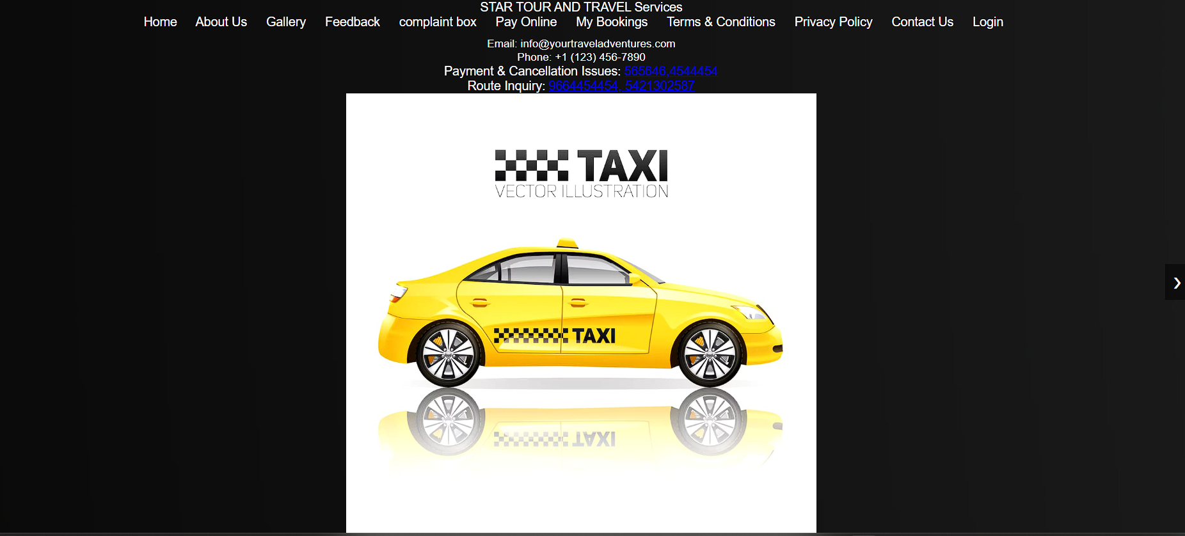

**Figure 4.1 home screen**

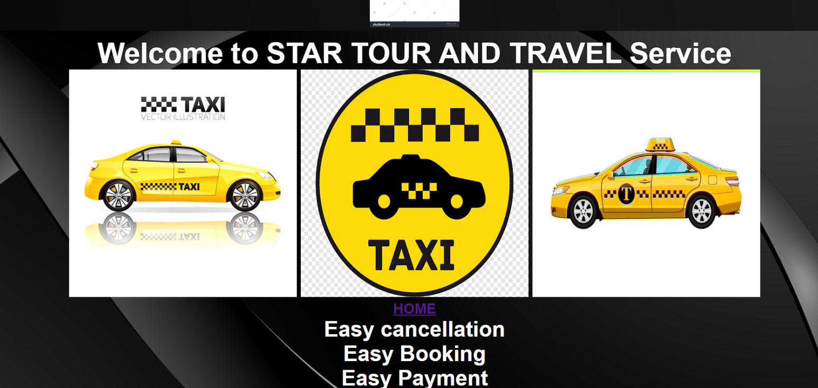

**Figure 4.2 home screen**

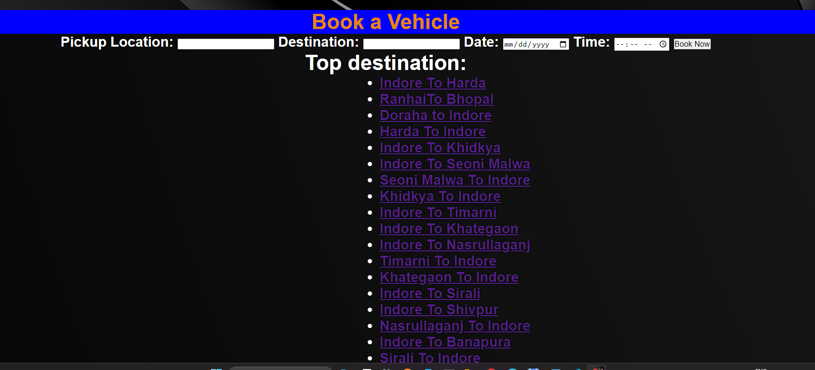

**Figure 4.3 home screen**

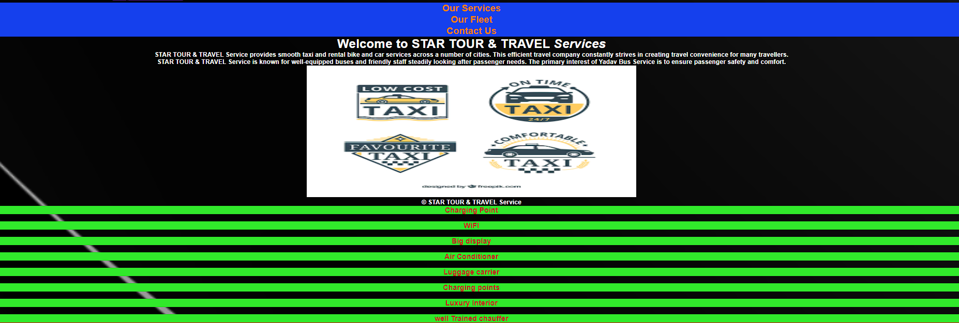

**Figure 4.4 home screen**



**Figure 4.5 home screen**

**Payment screen:**

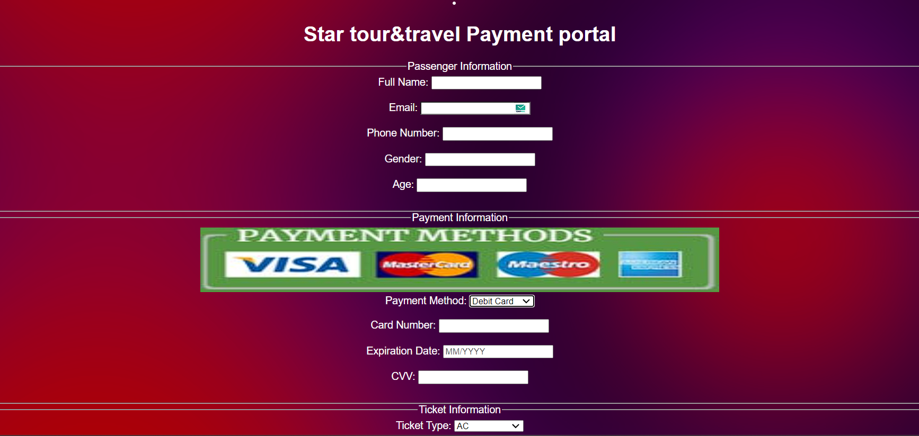

**Figure 4.6 payment screen**

**About us screen:**

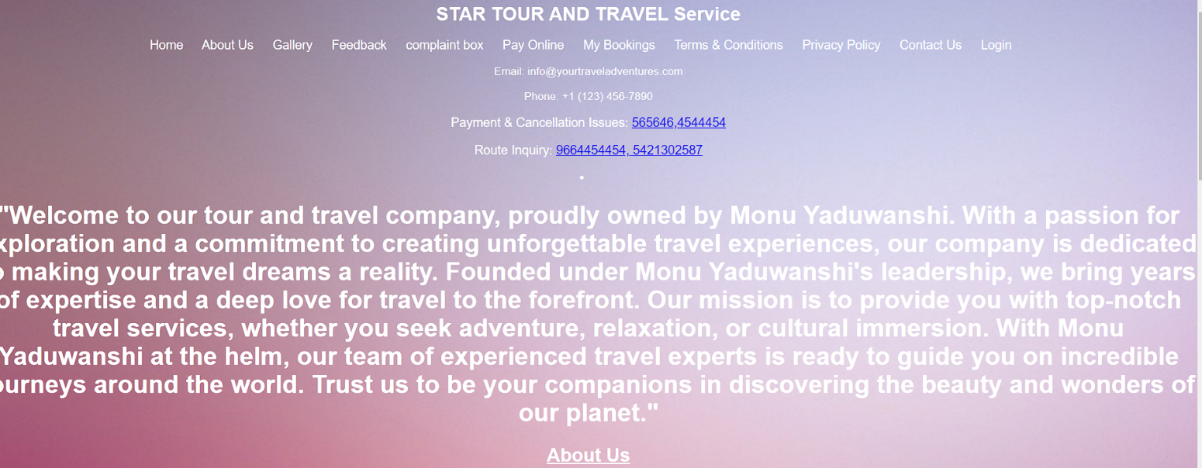

**Figure 4.7 about us screen**

**Feedback screen:**

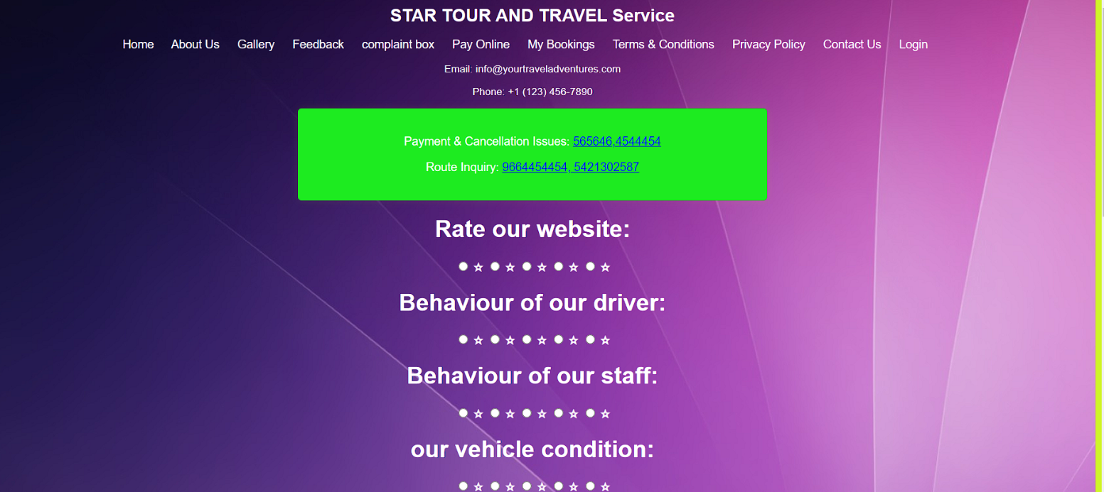

**Figure 4.8 feedback screen**

**Contact us screen:**

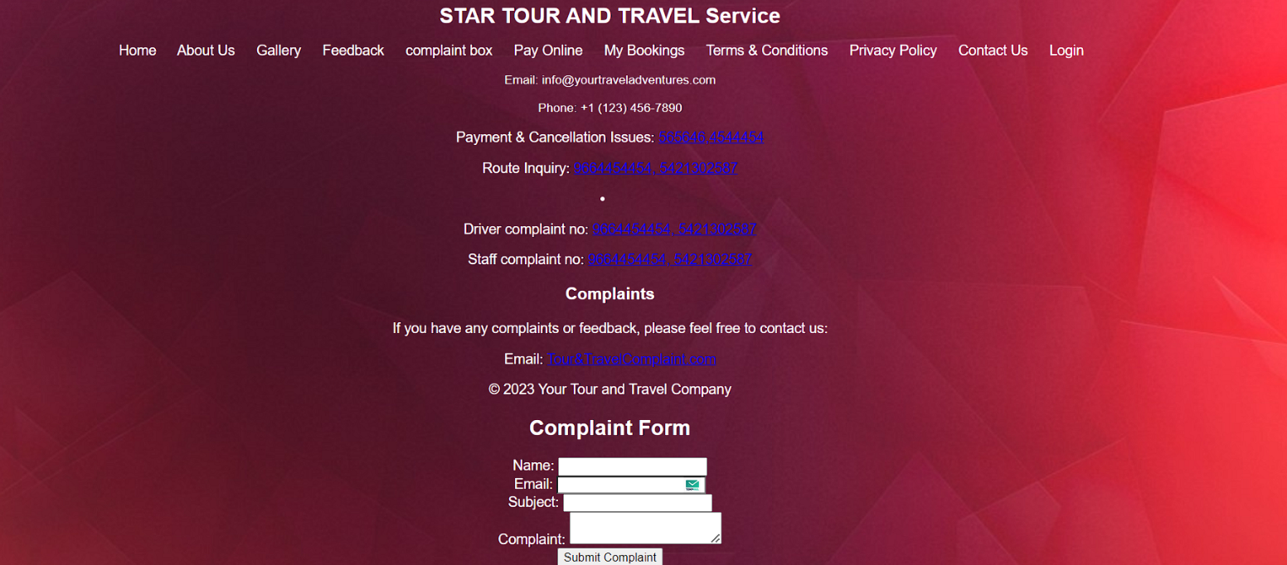

**Figure 4.9 contact us screen**

**Login page screen:**

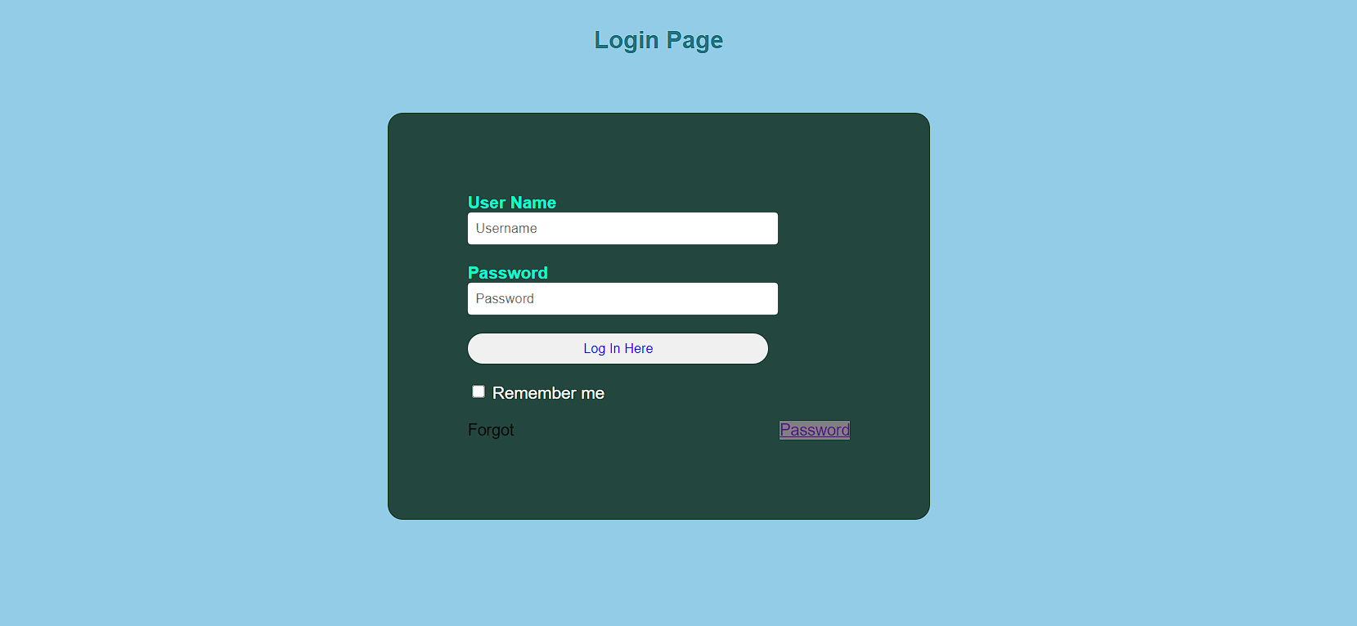

**Figure 4.10 login page screen**

 **CHAPTER-5**

**CONCLUSION & FUTURE WORK**

* 1. **CONCLUSION**

In conclusion, the development and implementation of the tour and travel website have successfully addressed the need for a centralized platform for both tour and travel owner and users.

Our objective is to make strong relationship with customers so that they can enjoy the holiday and journey of their dreams.

Our website helps to saves lots of time, now a days there is a fast process world any one can work quickly so, this project helps that people who are searching for buses and cabs , so they can easily fill up the form and search destination and different tourist place to travel

**CHAPTER- 6**

**FUTURE WORK**

* 1. **FUTURE WORK**

1. Expansion into Additional Services: Individual airlines, hotels, bed and breakfasts, cruise lines, automobile rental companies, and other travel-related service.are added on our site soon
2. [**Responsive & Mobile-Friendly Design**: With about half of internet traffic coming from mobile devices, it’s crucial for travel websites to operate smoothly across all devices and screen types](https://wptravelengine.com/must-have-features-for-travel-websites/).
3. [**Smart Booking Process**: Setting up a smart booking system with varied payment options and unlimited trip packages is almost mandatory](https://wptravelengine.com/must-have-features-for-travel-websites/)
4. [**Clear and Structured Website Navigation**: This helps users easily find the information they’re looking for](https://wptravelengine.com/must-have-features-for-travel-websites/)
5. [**SEO Friendliness**: This helps improve the visibility of the website on search engines](https://wptravelengine.com/must-have-features-for-travel-websites/)
6. [**Effective Payment Integration**: This ensures a smooth transaction process for users](https://wptravelengine.com/must-have-features-for-travel-websites/)
7. [**Effective and Straightforward Search Filters**: This helps users find the best deals for their next holiday](https://wptravelengine.com/must-have-features-for-travel-websites/)
8. [**Predictive Search**: This provides users with suggestions as they type in the search bar](https://wptravelengine.com/must-have-features-for-travel-websites/)
9. [**Trip Weather Forecast**: This provides users with weather information for their chosen destination](https://wptravelengine.com/must-have-features-for-travel-websites/)
10. [**Booking Details & Email Notification**: This keeps users informed about their booking status](https://wptravelengine.com/must-have-features-for-travel-websites/)

## REFERENCES

###### W3School:

https://[www.w3schools.in/](http://www.w3schools.in/)

###### GeeksforGeeks:

[www.geeksforgeeks.org/computer-science-projects/](http://www.geeksforgeeks.org/computer-science-projects/)

###### Youtube :

https://[www.youtube.com/results?search_query=project+for+website+development](http://www.youtube.com/results?search_query=project%2Bfor%2Bwebsite%2Bdevelopment)

## PROJECT SUMMARY

***About Project***

|  |  |
| --- | --- |
| **Title of the project** | Star tour and travel |
| **Semester** | 3rd |
| **Members** | 1 |
| **Team Leader** | Monu Yaduwanshi |
| **Describe role of every member in the project** | Monu Yaduwanshi **: -** Planning, Designing,  Front-End  Testing and Deployment |
| **Project Type**  **(Desktop Application, Web Application, Mobile App, Web)** | Web Application |

***Tools &Technologies***

|  |  |
| --- | --- |
| **IDE used**  **(With version)** | VS Code (Version 5.0.2) |
| **Front End Technologies (With version, wherever Applicable)** | HTML, CSS JAVASCRIPT, |
| **Back End Technologies (With version, wherever applicable)** | NA |
| **Database used**  **(With version)** | NA |

***Write project narrative covering above mentioned points***

The project ‘Star Tours and Travels services’ is developed to replace the currently existing system, which helps in keeping records of the customer details of destination as well as payment received. This application is develop to provide best travelling services to the customers and travel agents. We have developed tours and travel management system to provide a search platform where a tourist can find their tour places according to their choices. This system also helps to promote responsible and interesting tourism so that people can enjoy their holidays at their favorable places

**Monu Yaduwanshi 0187CS221126**